

**Team #59**

**Midterm Project Report**

**Team members:**

**Sarvar Khursandov U1810131 (Team leader)**

**Makhmudbek Rasulov U1810193**

**Javokhir Rasulov U1810061**

**Qudrat Nosirov U1810073**

**Asrorjon Pirmukhamedov U1810090**

**Introduction**

This assignment report contains information about the process of completing midterm project in which we were supposed to implement a code for given Raspberry Pi Cart.

Our main goal of this midterm project is to achieve stable process of following the yellow line in the map and avoid obstacles in each zones in the way of the cart. In order to arrive to the finish line and fulfill all requirements, we should use IR sensors and DC motor.

**Team member roles:**

|  |  |  |  |
| --- | --- | --- | --- |
| **Team Mission Statement** | | | |
| **Team #** | **59** | **Leader** | **Sarvar Khursandov** |
| **Name** | | **Main Responsibility** | |
| Khursandov Sarvar and Rasulov Makhmudbek | | both of them have strong knowledge of software development. They were responsible for code optimizations and creating new functions. | |
| Javokhir Rasulov | | contributed in hardware related aspects and problems. Tested sensors. | |
| Nosirov Qudrat | | responsible for meetings. Distributed tasks. Was responsible for report and research. | |
| Pirmukhamedov Asrorjon | | tested code and all sensors. Researched data from resources and helped with problem solving. Helped with report. | |

**Team minutes:**

|  |  |  |  |  |  |  |
| --- | --- | --- | --- | --- | --- | --- |
| **Team Minutes** | | | | | | |
| **Team #** | **59** | **Leader** | **Sarvar Khursandov** | | | |
| **Main goal** | The main purpose of the team is to complete tasks of the midterm project with fulfilling all requirements. | | | | | |
| **Purpose of the meeting** | Familiarization with the project, scheduling meetings | Starting coding process and researches | Completing  A and B zones. | Completing  C and D zones. | Testing day!  Solving emerged problems. | Final tests and wrapping everything up |
| **Meeting time** | 04.02.22  15:00 – 18:30 | 06.02.22  16:00 –18:30 | 08.02.22  15:00 – 19:00 | 10.02.22  16:30 – 20:00 | 12.03.22  15:30 – 18:30 | 14.03.22  16:30 – 20:00 |
| **Participation** | **ALL** | **ALL** | **ALL** | **ALL** | **ALL** | **ALL** |

**Process:**

What we should do in this project is to insert our code to the Raspberry Pi Cart and using ultrasonic, DC motors and IR sensors, go from starting point to the finish line and avoid obstacles when it is needed.

In zone A, car should go straight until sensor detects first obstacle. I should stop and start moving only after obstacle removal.

In zone B, car should make a circle following a line and go the zone C.

In zone C, it should follow the line until sensor detects second obstacle, then car should avoid this obstacle and continue movement.

Finally, in zone D car should stop the motors after detection last obstacle .

**In order to accomplish this task we used IR sensors, ultrasonic and DC motor.**

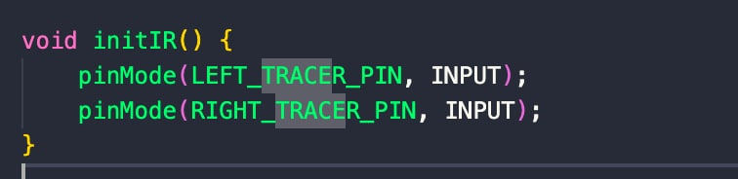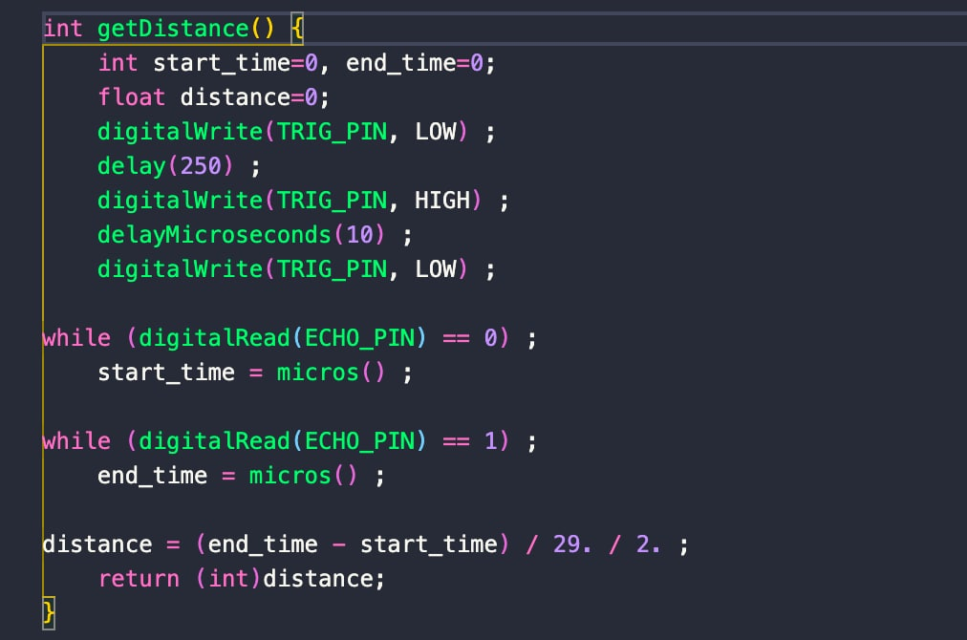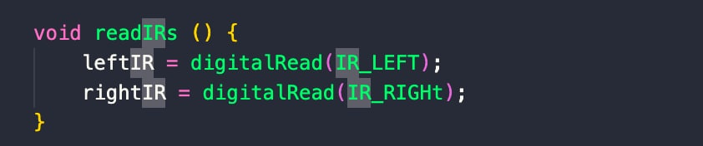

**The whole logic for car moving from starting point to the end line is divided into 3 parts:**

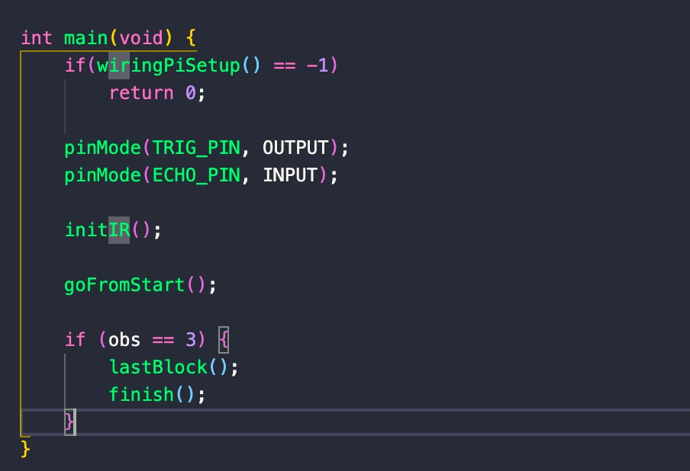

**goFromStart() function is responsible for starting movement and stopping when first obstacle is detected:**

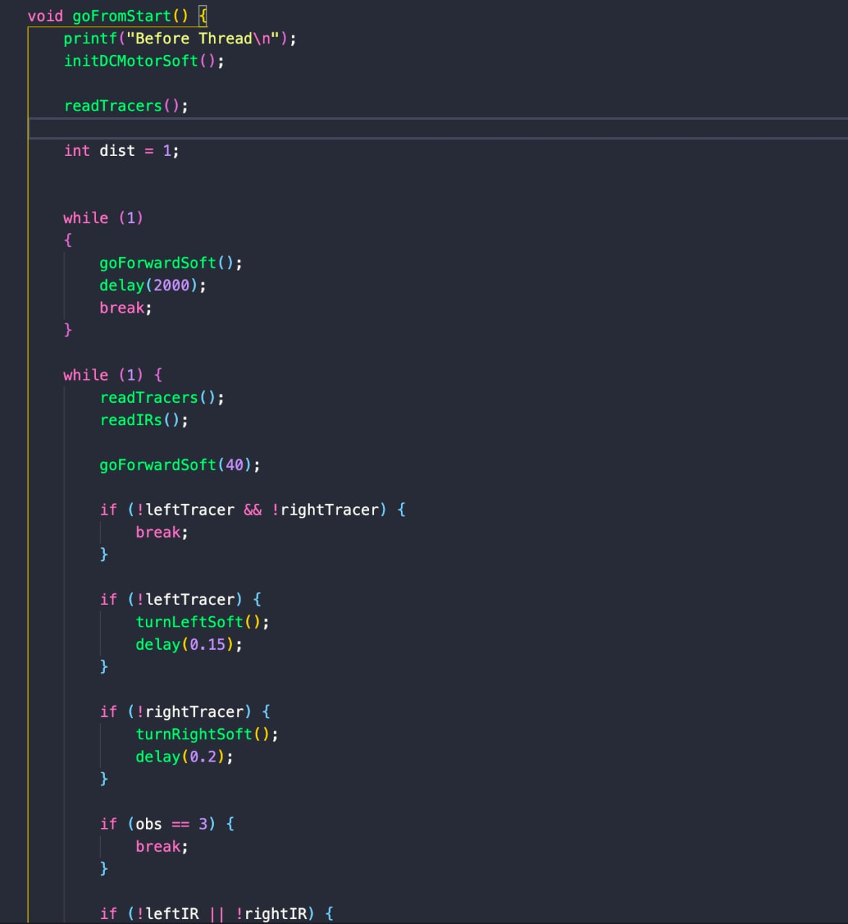

**Function lastBlock() is responsible for avoiding second obstacle:**

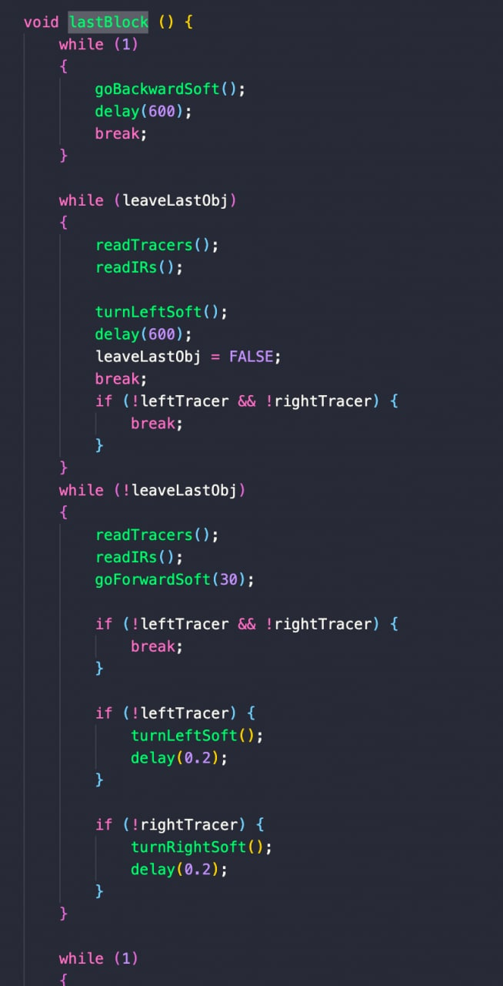

**Function finish() is responsible for stopping motor after detecting the last obstacle:**

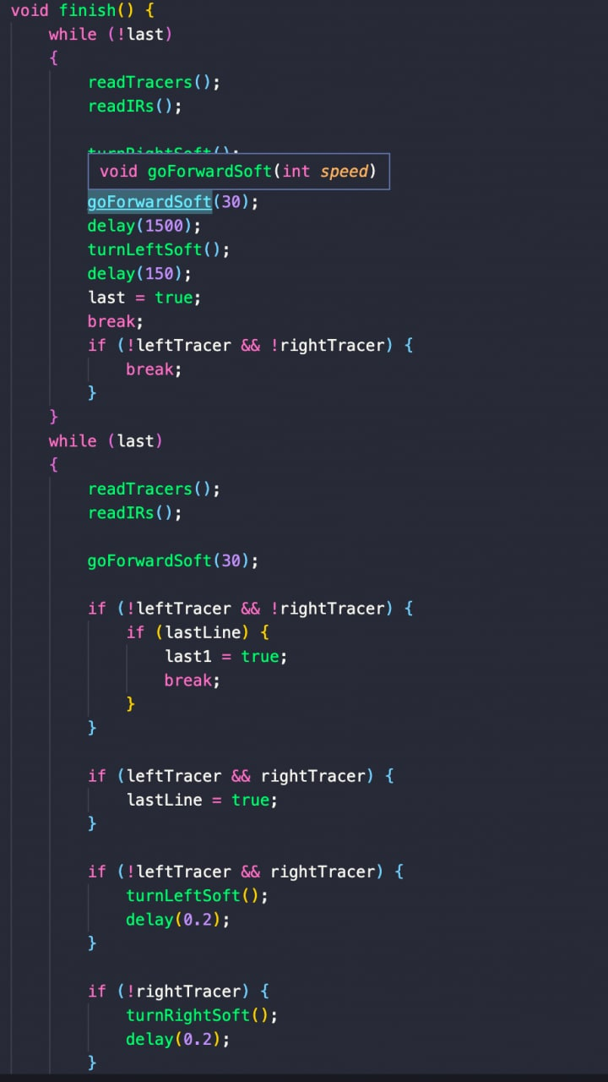

**Images from testing runs:**

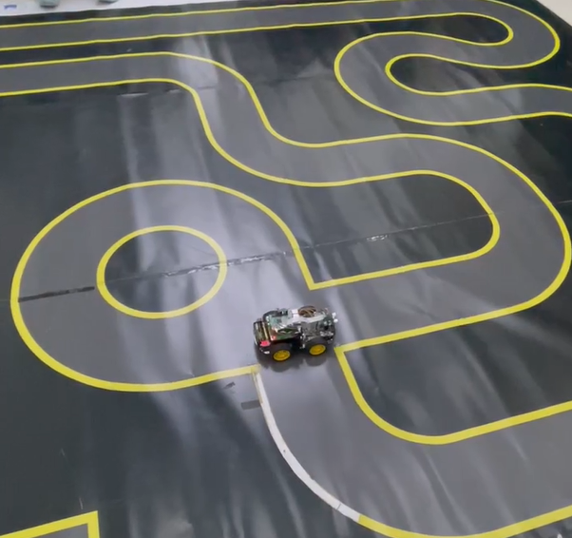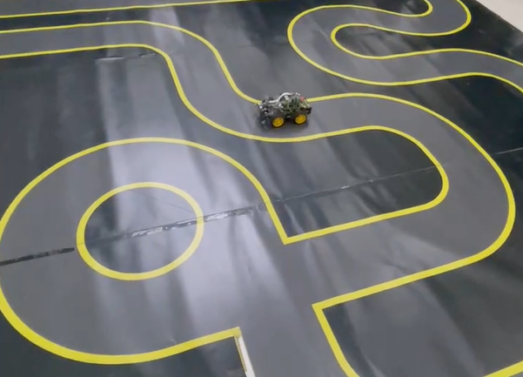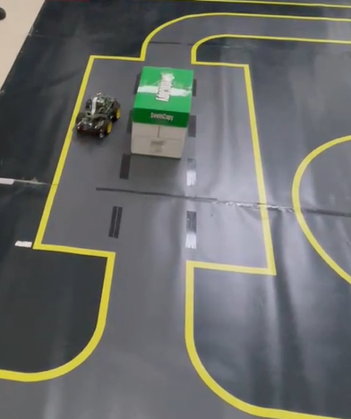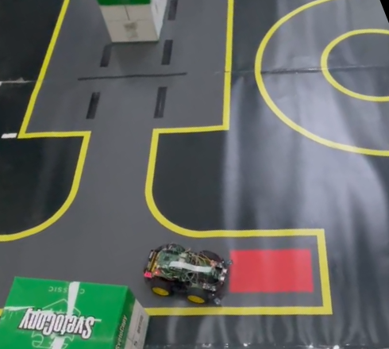

**Team Rules:**

**Rule 1: Open mindedness**

The work process is determined by every team member suggestions of good decisions during the process of work and not by one member.

**Rule 2: Exchange policy**

Every team member is obliged with a task, however If someone is in difficulty during certain stage, other team member should help and they should exchange roles for a period of time

**Rule 3: Effectiveness**

If there are multiple drawbacks and errors during the test and if nothing goes on, the work must be put to pause and moved to analyzation session with members all together that longs 20 minutes

**Rule 5: Organization**

Every work or assignment should be organized and put through in details before it is started. Ignoring small details results in additional errors and time loss.

**Conclusion**

Working with IR sensors and DC motor in this project was extremely useful experience for every member of our team. Throughout the process of programing, we encountered to the different problems but we managed to solve each of them, since every member did their best to finish our task. In overall, this project assignment was quite informative and we gained tons of useful knowledge.